Alaska Indoor Gardening Curriculum

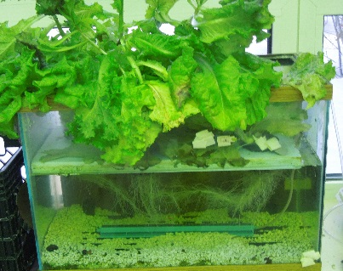
Floating Platform Hydroponic System Directions
Materials Needed:
- Rockwool, 12-15 cubes
- Plant Seed (lettuce or herbs but possibly peas too)
- Garden seedling plant tray
- 10-25 gallon Aquarium(s) or Sturdy Plastic Totes
- Styrofoam Sheet (1.5 inches thick to house growing bed cups)
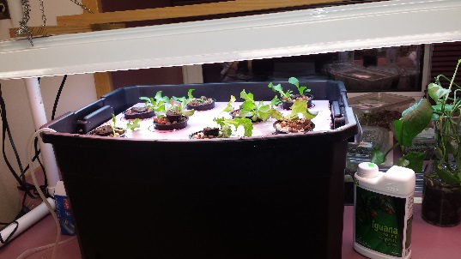
- 8-10 Hydroponic Net Pots (pictured right, bottom)
- Knife or box cutter
- Drill and Hole Saw bit – Sized according to your net pot size.
- Sharpie Marker
- Grow Light and Stand, T-5 or LED Lights suggested
- Timer for light
- Water
- Spray Bottles
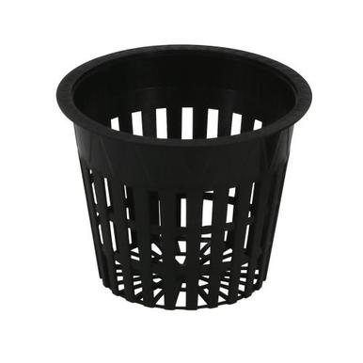
- Hydroponic Nutrient Mix (liquid or dry)
- Aquarium Gravel (pre-washed and rinsed)
- Fish Tank Air Stone and Aquarium Pump System
- Dark Paper (to block out 3 sides of aquarium if using aquarium to prevent algae.

Preparation: Start seeds in rockwool cubes ahead of time. It’s best to do this in a garden seedling plant tray with the bottom of the rockwool cubes sitting in water to absorb into the media. Start the grow light after the seeds sprout. Be sure to place the grow light no farther than 2” above the growing seedlings. Seedlings should have their secondary leaves before placing in the floating platform system. Ideally the roots should be coming out of the bottom of the rockwool before placing them in the system.

Procedure:

- Cut the Styrofoam using the box cutter fit the opening of the tank or tote. Cut the float about ½-1” smaller than the opening so that it won't bind up when the water level changes.

- Measure the cups opening diameter first by placing opening side down on the Styrofoam, trace with the sharpie. Draw another circle slightly smaller on the inside of the traced circle with the sharpie.

- Cut the holes in the float to the proper size for the plastic cups or plant pots that you are using. Note: you want the bottoms of the cups to hang below the bottom of the float but not fall through.

- Add pre-washed and rinsed aquarium gravel to the bottom of the aquarium or tote.

- Attach free end of tubing to air pump and Add air stone with the tubing. Immerse the airstone in the water on top of the gravel Plug in air pump to outlet and make sure that there are bubbles coming from the air stone. Set the airstone in the bottom of the aquarium or tote, sitting on top of the aquarium rocks. Note: NEVER submerge the air pump in water as electrical shock could occur.

- Fill the aquarium or tote with measured room temperature water to 5-7 inches below the rim of the container.

- Add nutrient mixture to water in the aquarium or tote. Read directions on the nutrient container for exact amounts to add based on the gallons of water added to the tank. Stir it gently and give the nutrient time to mix with the water. Check pH and adjust accordingly. Note: The required pH value will vary depending on the requirements of the plant.

- Place the net pots into the floating platform, then place the platform on top of the water.

- Plug in and turn on the airstone pump.

- Set plant light above the system, put light on a timer. 12 hours on and 12 hours off is a good light schedule for most leafy plants.

- Tape on dark construction paper to the back, left and right sides of the aquarium.

- Weekly/daily maintenance will be required including adding water and nutrients, pH monitoring, flushing out accumulated nutrients, etc…

Maintenance and Feeding Instructions
- Monitor water levels and replace water, add nutrients to water before adding according to directions on container, as necessary.

- Recheck pH and adjust if necessary.

- Watch leaves for any browning or yellowing. This will let you know if you have enough or too much nutrient in your water.

- Visit https://www.youtube.com/watch?v=Webb1cjen6s or https://www.nosoilsolutions.com/common-issues-hydroponic-gardeners-face/ for suggestions on troubleshooting growing issues.

